# [**Quick Start Guide**](https://docs.rakwireless.com/Product-Categories/WisGate/RAK7249/Quickstart/#product-configuration)

## [#](https://docs.rakwireless.com/Product-Categories/WisGate/RAK7249/Quickstart/#prerequisites)**Prerequisites**

### [#](https://docs.rakwireless.com/Product-Categories/WisGate/RAK7249/Quickstart/#what-do-you-need)**What do you need?**

1. RAK7249 WisGate Edge Max
2. A Windows/Mac OS/Linux Computer

### [#](https://docs.rakwireless.com/Product-Categories/WisGate/RAK7249/Quickstart/#what-s-included-in-the-package)**What's included in the Package?**

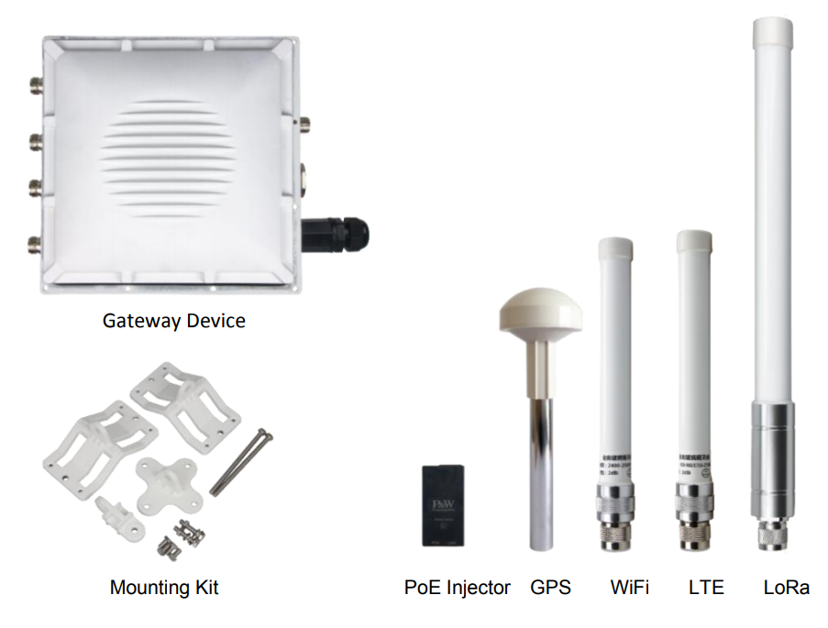

**Figure 1:** RAK7249 Package Contents

## [#](https://docs.rakwireless.com/Product-Categories/WisGate/RAK7249/Quickstart/#product-configuration)**Product Configuration**

### [#](https://docs.rakwireless.com/Product-Categories/WisGate/RAK7249/Quickstart/#gateway-installation-guide)**Gateway Installation Guide**

#### [#](https://docs.rakwireless.com/Product-Categories/WisGate/RAK7249/Quickstart/#assembly)**Assembly**

1. Fix the support plate on the base with three M3x6 screws.

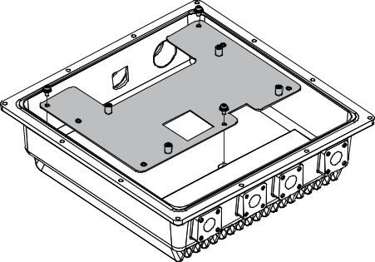

**Figure 2:** RAK7249 WisGate Edge Max Support Plate Attachment

1. Install the main board with four M3x6 screws.

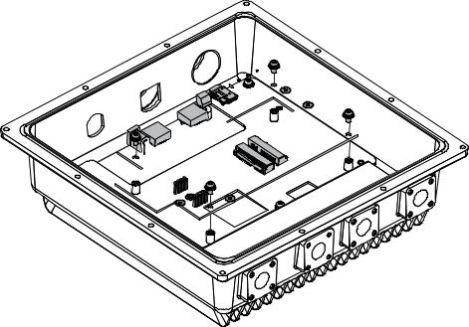

**Figure 3:** RAK7249 WisGate Edge Max Main Board Installation

1. Install the LoRa cards (for example RAK833), the motherboard supports two LoRa cards, the first slot is for LoRa card of SPI type, the second slot is for LoRa card of USB type.

📝 NOTE

If there is only one LoRa card (SPI type), please install it in the first slot.

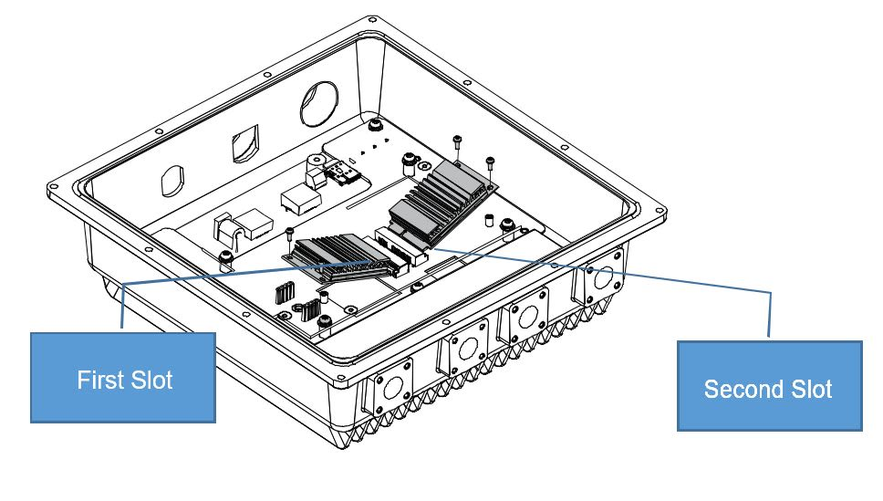

**Figure 4:** RAK7249 WisGate Edge Max LoRa Card Installation

1. Installation of RF cables, Ethernet cable and reserved hole plugs.
2. If your board supports the cellular function, you can install your SIM card into the motherboard’s SIM card slot.

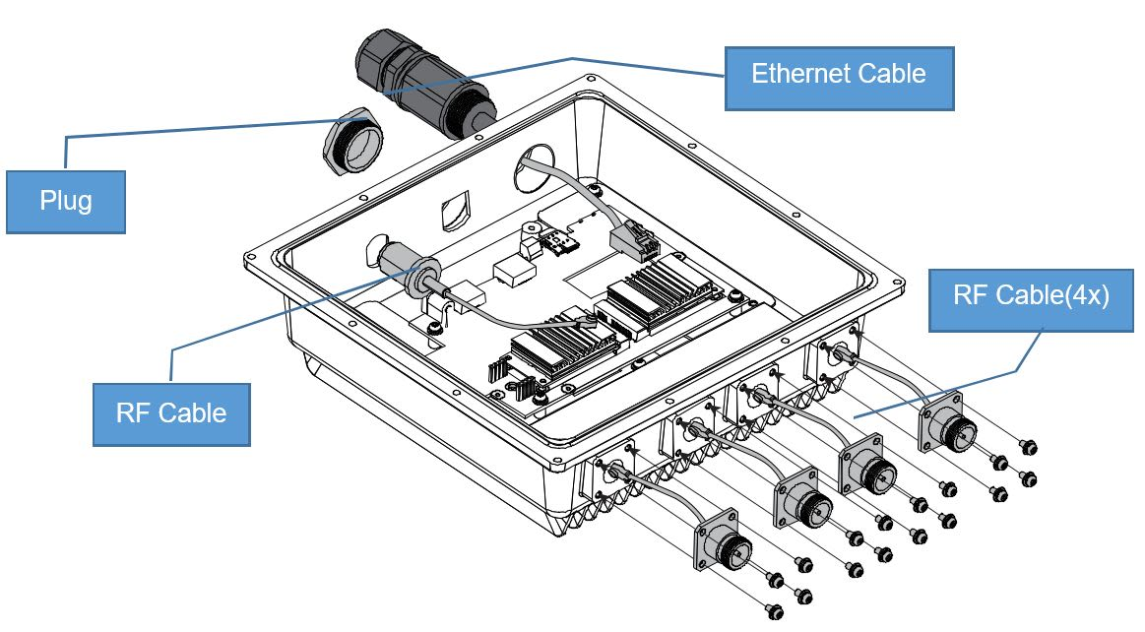

**Figure 5:** RAK7249 WisGate Edge Max Cable Installtion

1. Connect the cable to the motherboard. The connectors on motherboard are as follows. Connect the cables one by one.

📝 NOTE

ou must use the WiFI-MAIN connector to connect the WiFi Antenna.

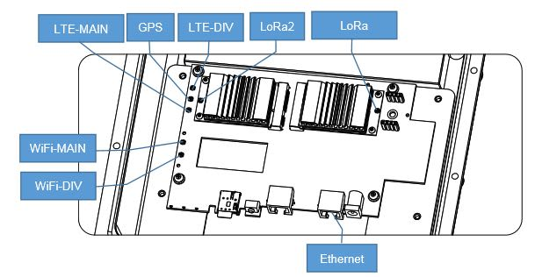

**Figure 6:** RAK7249 WisGate Edge Max Interfacing

1. If you have a Backup Battery Kit, connect with the Backup Battery to the motherboard.
2. Close the top cover with 12PCS M4x12 screws

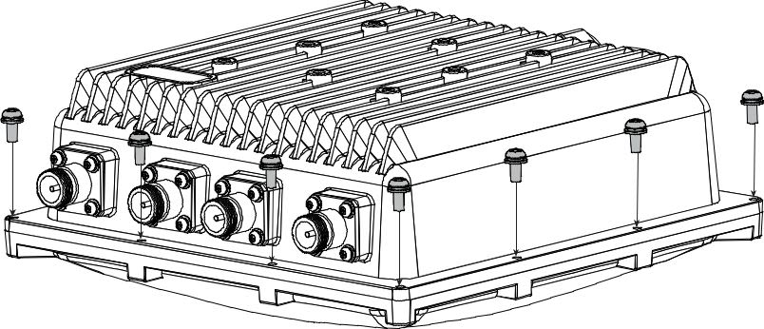

**Figure 7:** RAK7249 WisGate Edge Max Top Cover Sealing

#### [#](https://docs.rakwireless.com/Product-Categories/WisGate/RAK7249/Quickstart/#mounting)**Mounting**

📝 NOTE

All the necessary components (bolts, washers, nuts) come with the mounting kit.

1. Fix the device bracket to the backside of the enclosure with four M6x12 screws.

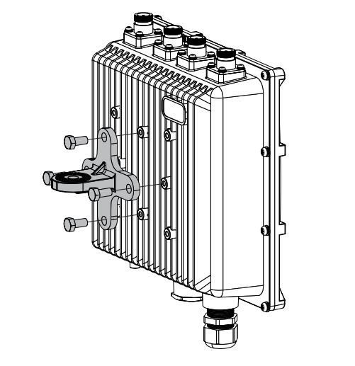

**Figure 8:** RAK7249 WisGate Edge Max Back Panel to Bracket Attachment

1. Tighten the pole clamp with hexagonal M6x110 bolts , washers and nuts.

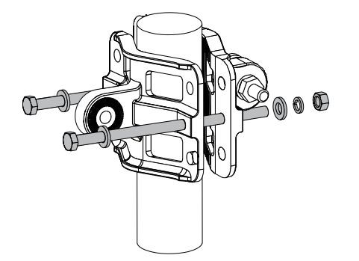

**Figure 9:** RAK7249 WisGate Edge Max Pole Clamp Guide

1. Connect the clamp and the bracket on the backside of the casing with hexagonal M6x30 bolts , washers and nuts.

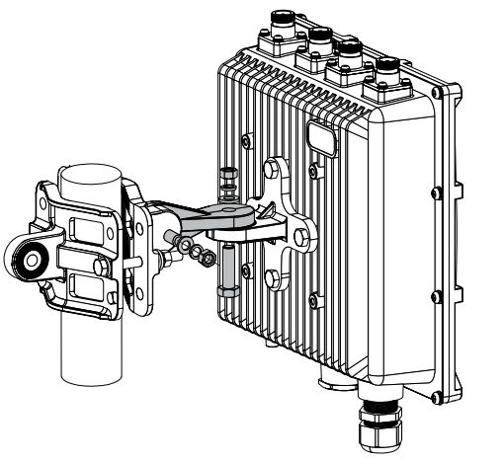

**Figure 10:** RAK7249 WisGate Edge Max Back Panel to Pole Attachment

#### [#](https://docs.rakwireless.com/Product-Categories/WisGate/RAK7249/Quickstart/#optional-accessories)**Optional Accessories**

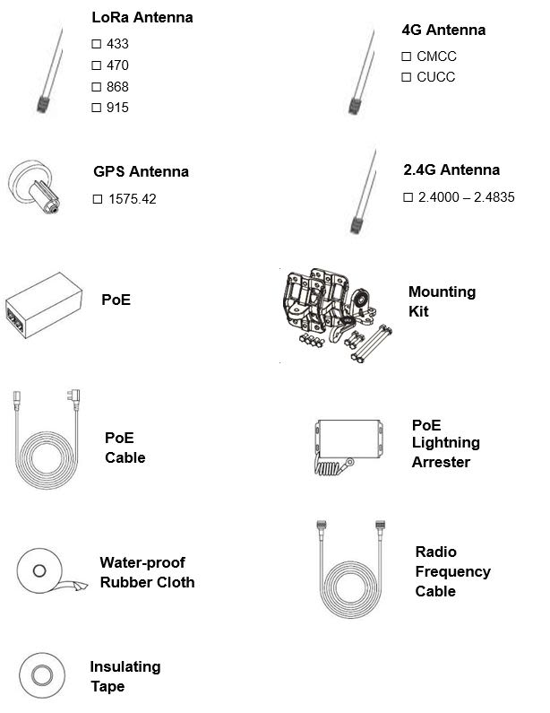

**Figure 11:** RAK7249 WisGate Edge Max Optional Accessories

### [#](https://docs.rakwireless.com/Product-Categories/WisGate/RAK7249/Quickstart/#solar-panel-and-battery-kit-installation)**Solar Panel and Battery Kit Installation**

This document shows the step-by-step guide on how to set-up the Solar Panel and Battery Kit used for the RAK7249 - Macro Outdoor Gateway. Such steps must be thoroughly read and understood to avoid damaging the device.

#### [#](https://docs.rakwireless.com/Product-Categories/WisGate/RAK7249/Quickstart/#package-list)**Package List**

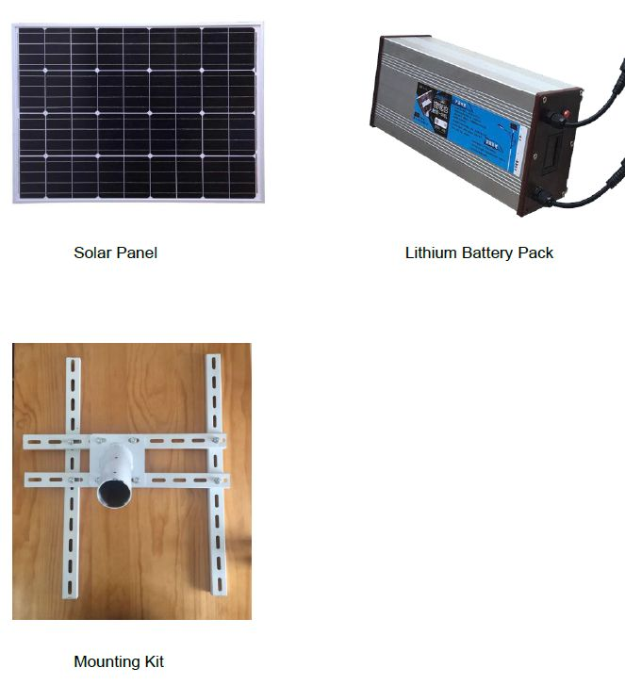

**Figure 12:** RAK7249 WisGate Edge Max Main Board Installation

#### [#](https://docs.rakwireless.com/Product-Categories/WisGate/RAK7249/Quickstart/#specifications)**Specifications**

##### [#](https://docs.rakwireless.com/Product-Categories/WisGate/RAK7249/Quickstart/#solar-panel)**Solar Panel**

###### [#](https://docs.rakwireless.com/Product-Categories/WisGate/RAK7249/Quickstart/#_1-dimensions)**1. Dimensions**

The dimension of the Solar Panel included in the kit is 665 x 815 millimeter. Provided in the image below is the detailed dimensions of the solar panel for extended functions.

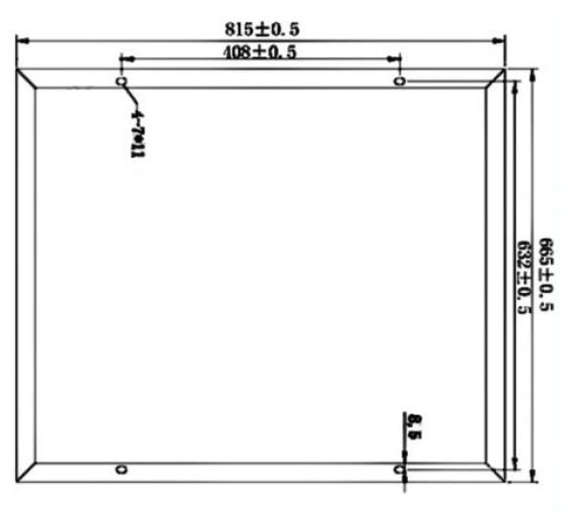

**Figure 13:** Solar Panel Dimensions

###### [#](https://docs.rakwireless.com/Product-Categories/WisGate/RAK7249/Quickstart/#_2-electrical-characteristics)**2. Electrical Characteristics**

The table below is the electric characteristics of the Solar Panel included in the kit. It is best advised to have your electric parameters within the set values to maximize its functions and to avoid damage which could furtherly affect your RAK7249 - Macro Outdoor Gateway's performance.

|  |  |
| --- | --- |
| **Maximum Power (Pmax)** | **80 Watts** |
| Voltage at Pmax (Vmp) | 18 Volts |
| Current at Pmax (Imp) | 2.2 - 5.5 Amperes |
| Open Circuit Voltage (Voc) | 21.6 Volts |
| Short Circuit Current (Isc) | 2.3-6.5 Amperes |

##### [#](https://docs.rakwireless.com/Product-Categories/WisGate/RAK7249/Quickstart/#lithium-battery)**Lithium Battery**

###### [#](https://docs.rakwireless.com/Product-Categories/WisGate/RAK7249/Quickstart/#_1-dimensions-2)**1. Dimensions**

The dimensions of the Lithium Battery included in the kit is 140 x 90 x 350 millimeter.

###### [#](https://docs.rakwireless.com/Product-Categories/WisGate/RAK7249/Quickstart/#_2-operational-temperature)**2. Operational Temperature**

The operational temperature of the Lithium Battery is -20˚C ~ 60˚C. It is advised to have your ambient temperature be within this temperature range to avoid failures or damage to the battery.

###### [#](https://docs.rakwireless.com/Product-Categories/WisGate/RAK7249/Quickstart/#_3-electrical-characteristics)**3. Electrical Characteristics**

|  |  |
| --- | --- |
| **Nominal Output Voltage** | **12.6 Volts** |
| Nominal Output Current | 2 Amperes |
| Capacity | 50 Ah (Ampere-hour) |
| Charge Voltage | 18 Volts |

#### [#](https://docs.rakwireless.com/Product-Categories/WisGate/RAK7249/Quickstart/#installation-guide)**Installation Guide**

1. Install the bolts in the holes which are circled in red in the following image below. This will make an "H-shaped" base, for the Solar Panel to be mountable on the top. The circular pipe in the middle of the shape is meant to fit over a circular shaped pole, so the whole construction sits on top with the panel facing upwards on an angle.

📝 NOTE

Tighten the nuts and make sure that the rails that make up the base are holding tight against each other.

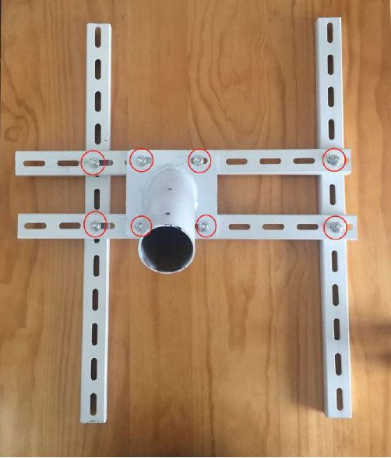

**Figure 14:** H-Shaped Nuts and Bolts Placement for the Bracket

1. Mount the battery on top of the two parallel rails in the middle. Make sure it is as close as possible to the middle of the construction. Fasten it to the rails with four bolts, each having a washer and a nut. Refer to the image below on how to insert the bolts into the railing that is part of the bottom of the battery casing.

⚠️ WARNING

Tighten the bolts as possible as the battery is quite heavy.

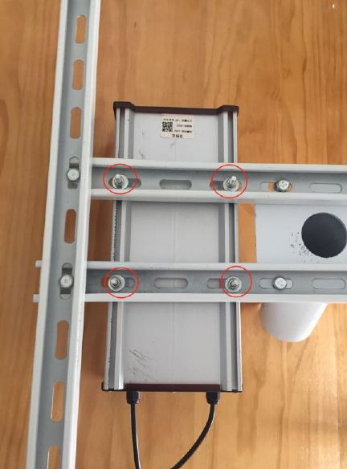

**Figure 15:** Mounting the Battery to the Bracket

1. Connect input port power cable of the Lithium Battery to the screw terminals on the back of the Solar Panel. The image below shows the connection on the back of the solar panel.

⚠️ WARNING

Make sure to follow the connection in the image below as interchanging the wires would reverse the polarity. Reversing the polarity when connecting the battery is dangerous and may cause fire.

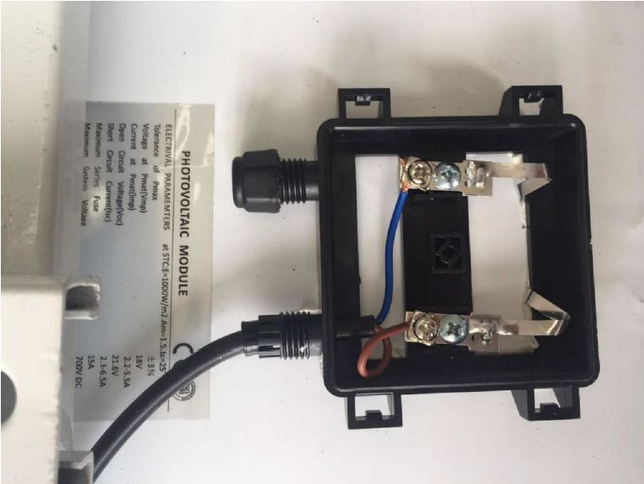

**Figure 16:** Lithium Battery Input Cord to Solar Panel Connection

1. The following image then shows where the cable connection between the solar panel entering the input terminal on the battery performed in Step 3.

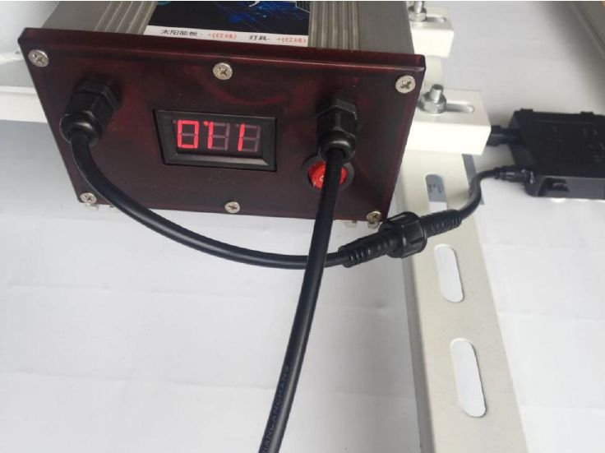

**Figure 17:** Lithium Battery to Solar Panel Outside Connection

1. Connect the Lithium Battery output terminal cable to the input power cable of the RAK7249 - Macro Outdoor Gateway as shown in the following figure.

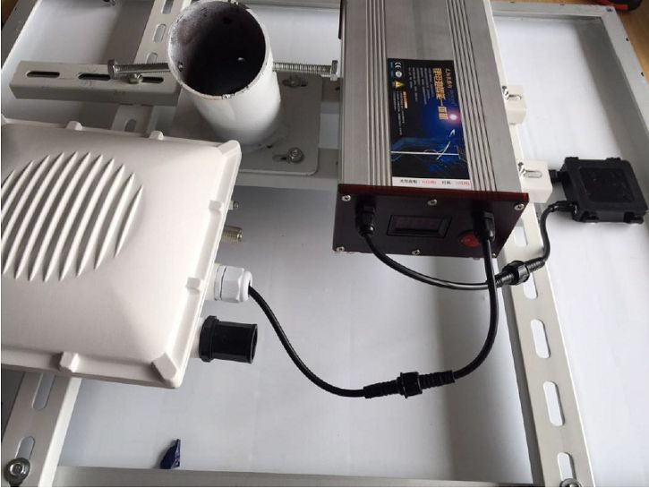

**Figure 18:** Lithium Battery Output Cord to RAK7249 - Marco Outdoor Gateway Connection

📝 NOTE

Your battery life will vary depending on local illumination intensity. For a 50Ah battery and an 80W solar panel, such as the ones used in the kit, the RAK7249 - Macro Outdoor Gateway should function for about 4 days. This is the worst case scenario where there is constant heavy rain and or constant presence of clouds.

📝 NOTE

If you live in extreme condition environment that result in operational time significantly less than 4 days, reconsider into increasing the battery capacity and installing a solar panel with greater power output to compensate such issues.

1. Mount the whole installation you have assembled on top of a circular pole. Put the panel facing up and insert the pole in the pipe opening on the bottom of the construction. Make sure the pole is of a sufficiently small diameter to fit with a recommended value of 65 millimeters. Use 6 pieces of M8-bolts to fix the bottom to the construction as shown in the image below.

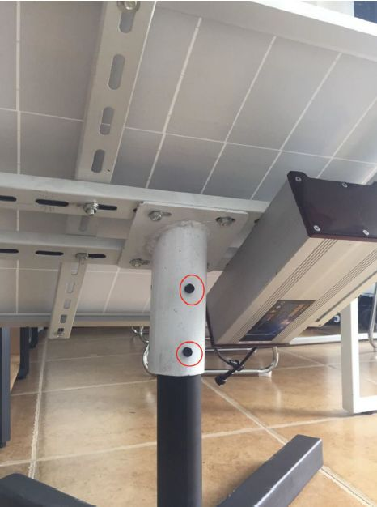

**Figure 19:** Installing Bolts in the Kit into the Vertical Circular Pole

### [#](https://docs.rakwireless.com/Product-Categories/WisGate/RAK7249/Quickstart/#lightning-protection)**Lightning Protection**

In this document, we will be discussing on how to setup your lightning surge protection system whether be your RAK7249 WisGate Edge Max situated outdoor or indoor. Such protection system must be taken into consideration to ensure a fully functional Gateway without interruption or damage from the lightings.

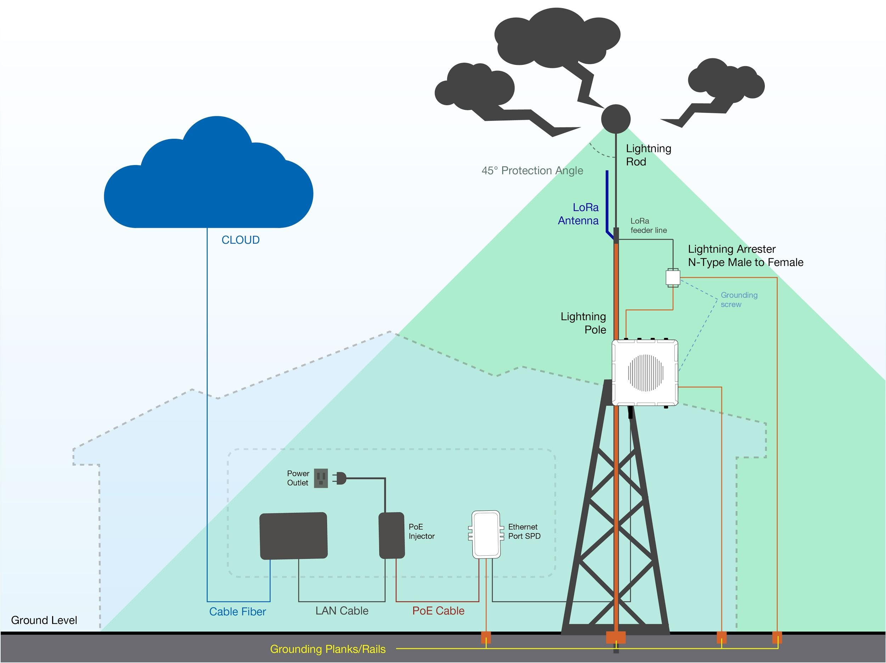

**Figure 20:** Full Lighting Protection Set-up Diagram

#### [#](https://docs.rakwireless.com/Product-Categories/WisGate/RAK7249/Quickstart/#outdoor-surge-protection-system)**Outdoor Surge Protection System**

##### [#](https://docs.rakwireless.com/Product-Categories/WisGate/RAK7249/Quickstart/#antenna-grounding)**Antenna Grounding**

RAKwireless recommends a lightning arrestor to be installed on all the antenna N-Type terminals (LoRa, LTE, Wi-Fi and GPS). It is recommended to use a 10-AWG or better grounding wire to connect the arrestor to the tower mounted LoRa antenna. The arrestors have to be Female to Male type in order to fit the antenna and housing connectors. Make sure you use a 10 AWG or better wire to connect the screw terminals of the arrestors to the grounding rail mounted on the building wall (grounding bar in case of field deployment as in the picture).

##### [#](https://docs.rakwireless.com/Product-Categories/WisGate/RAK7249/Quickstart/#gateway-grounding)**Gateway Grounding**

Additionally it is recommended to use another 10 AWG or better grounding wire to connect the screw terminal on the bottom right side of the Gateway casing to the grounding rail (bar).

📝 NOTE

No additional protection for the Ethernet cabling is required at the Gateway side. There is a surge protection system built-in (GDT + Anti-surge resistor).

#### [#](https://docs.rakwireless.com/Product-Categories/WisGate/RAK7249/Quickstart/#indoor-surge-protection)**Indoor Surge Protection**

For the purpose of protecting the indoor equipment and circuitry connected to the Gateway you need to install an Ethernet port SPD lightning arrester. It should be positioned along the cabling connecting the Gateway to the PoE injector. Make sure you connect its grounding wire terminal to an appropriate building grounding point. Thus your PoE injector and network switch/router should be surge protected. Please refer to the images in the diagram below for the Outdoor and Indoor portion of the surge protection system. Should you fail to adhere to the recommendations in this document RAKwireless carries no responsibility for any damage your equipment incurs due to lightning strike!

#### [#](https://docs.rakwireless.com/Product-Categories/WisGate/RAK7249/Quickstart/#recommended-equipment)**Recommended Equipment**

##### [#](https://docs.rakwireless.com/Product-Categories/WisGate/RAK7249/Quickstart/#lightning-arrestor-for-the-lora-lte-and-wi-fi-antennas)**Lightning Arrestor for the LoRa, LTE, and Wi-Fi antennas**

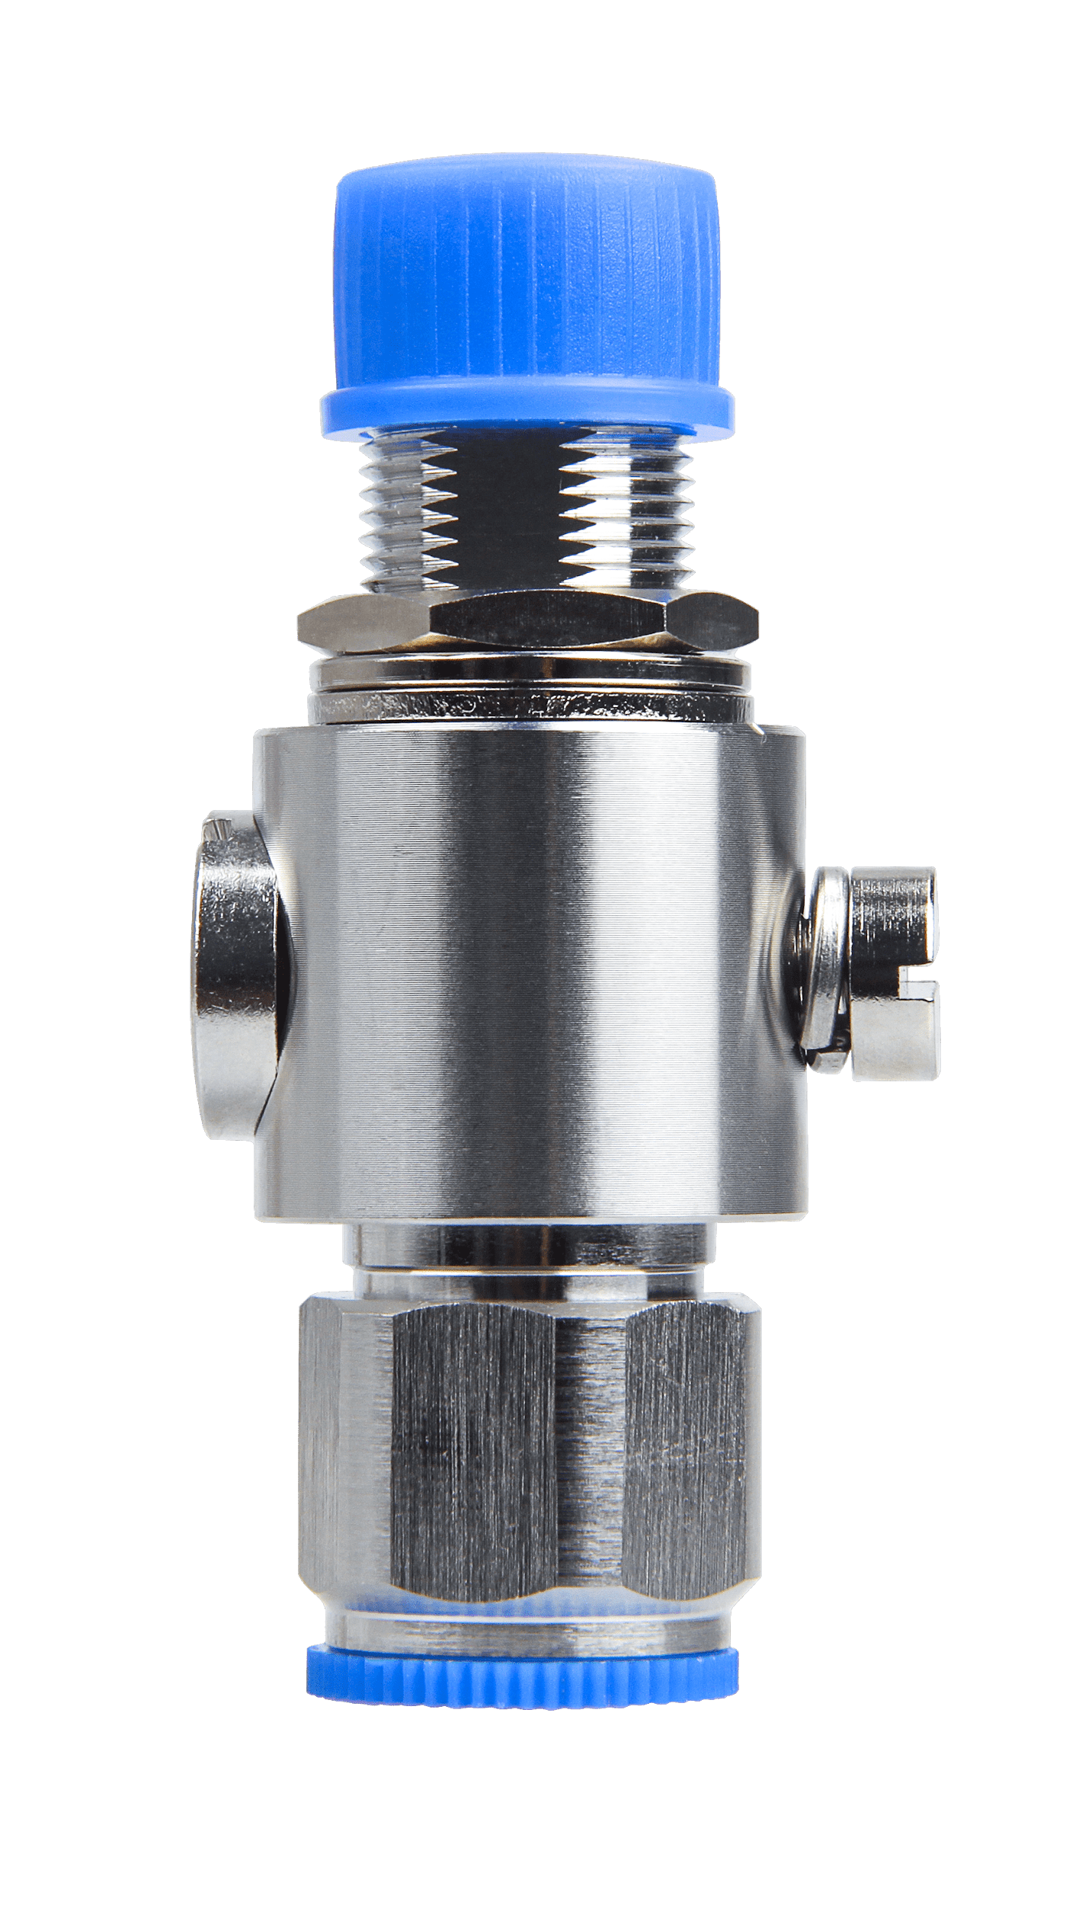

**Figure 21:** Lightning Arrestor for LoRa , LTE and Wi-Fi Antennas

[Buy a Lightning Arrestor For LoRa, LTE and Wi-Fi](https://store.rakwireless.com/products/lightning-arrestor)

This is a surge protective device for securing transceivers against over-voltage and surge current induced by bolts of lightning. RAKwireless recommends installing lightning arrestor on all N-type antenna terminals including LoRa, LTE, and 2.4G Wi-Fi antennas.

##### [#](https://docs.rakwireless.com/Product-Categories/WisGate/RAK7249/Quickstart/#lightning-arrestor-for-the-gps-antenna)**Lightning Arrestor for the GPS Antenna**

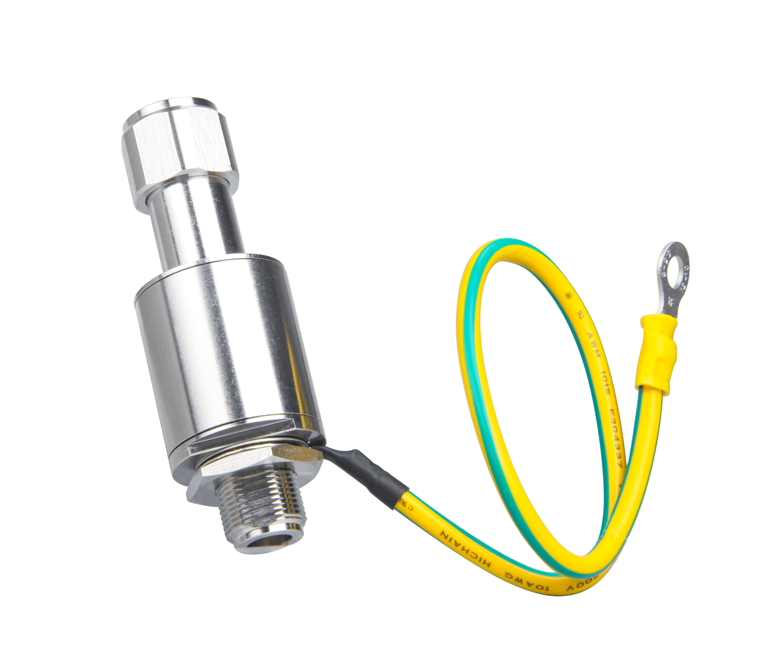

**Figure 22:** Lightning Arrestor for GPS

[Buy a Lightning Arrestor for GPS](https://store.rakwireless.com/products/lightning-arrestor-for-gps-antenna)

This lightning arrestor connects between antenna and GPS receiver. A surge protection device for securing transceiver against transients, over-voltage, and surge currents induced by bolts of lightning.

For the purpose of protecting the indoor equipment and circuitry connected to the gateway, you need to install an Ethernet port SPD lightning arrestor.

By adopting a high pass filter, this product can effectively suppress the low-frequency interference induced by lightning while letting through the GPS signal with low insertion loss. A transient suppression device (TVS) and a gas discharge tube (GDT) is adopted for the protection of the DC feed circuit.

##### [#](https://docs.rakwireless.com/Product-Categories/WisGate/RAK7249/Quickstart/#antenna-feeder-line)**Antenna Feeder Line**

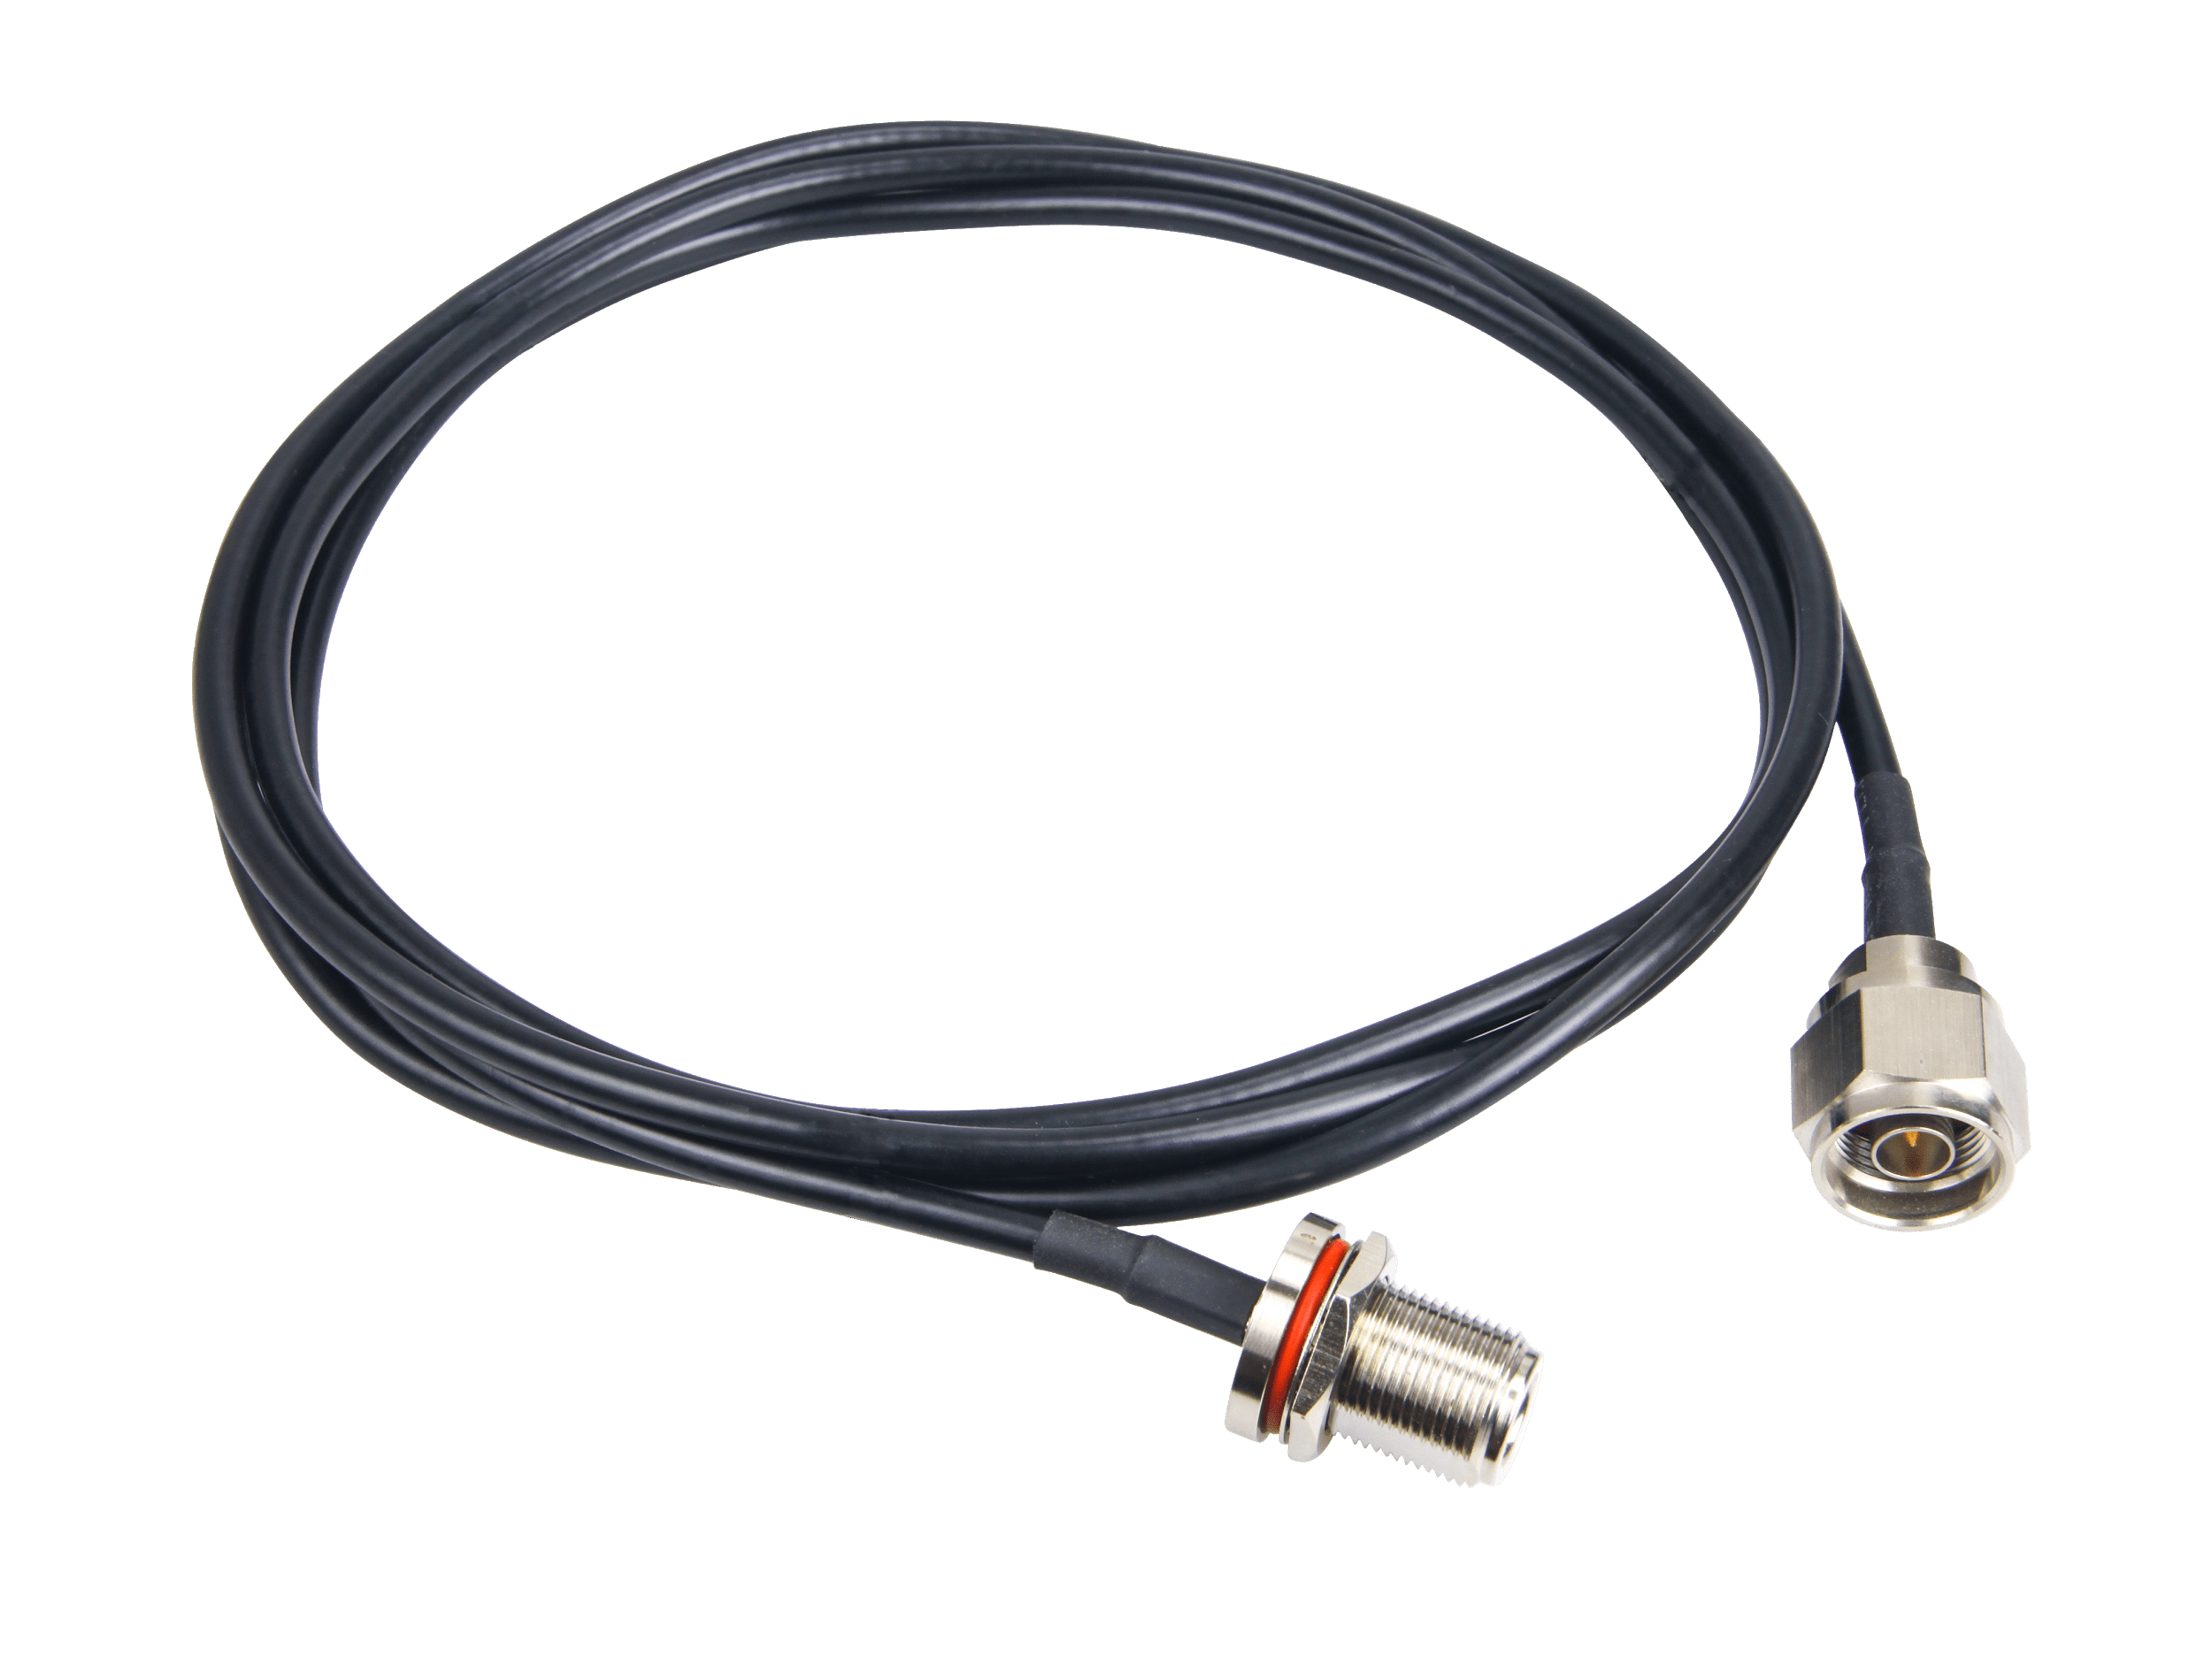

**Figure 23:** Antenna Feeder Line

[Buy an Antenna Feeder Line](https://store.rakwireless.com/products/antenna-feeder-line)

Antenna Feeder Line for RAK7249 Lightning Protection. This antenna feeder line is an NJ-NF adapter cable with a length of 1.5m. It is an RG8 coaxial cable with N-type connector as the antenna feeder.

##### [#](https://docs.rakwireless.com/Product-Categories/WisGate/RAK7249/Quickstart/#signal-surge-protective)**Signal Surge Protective**

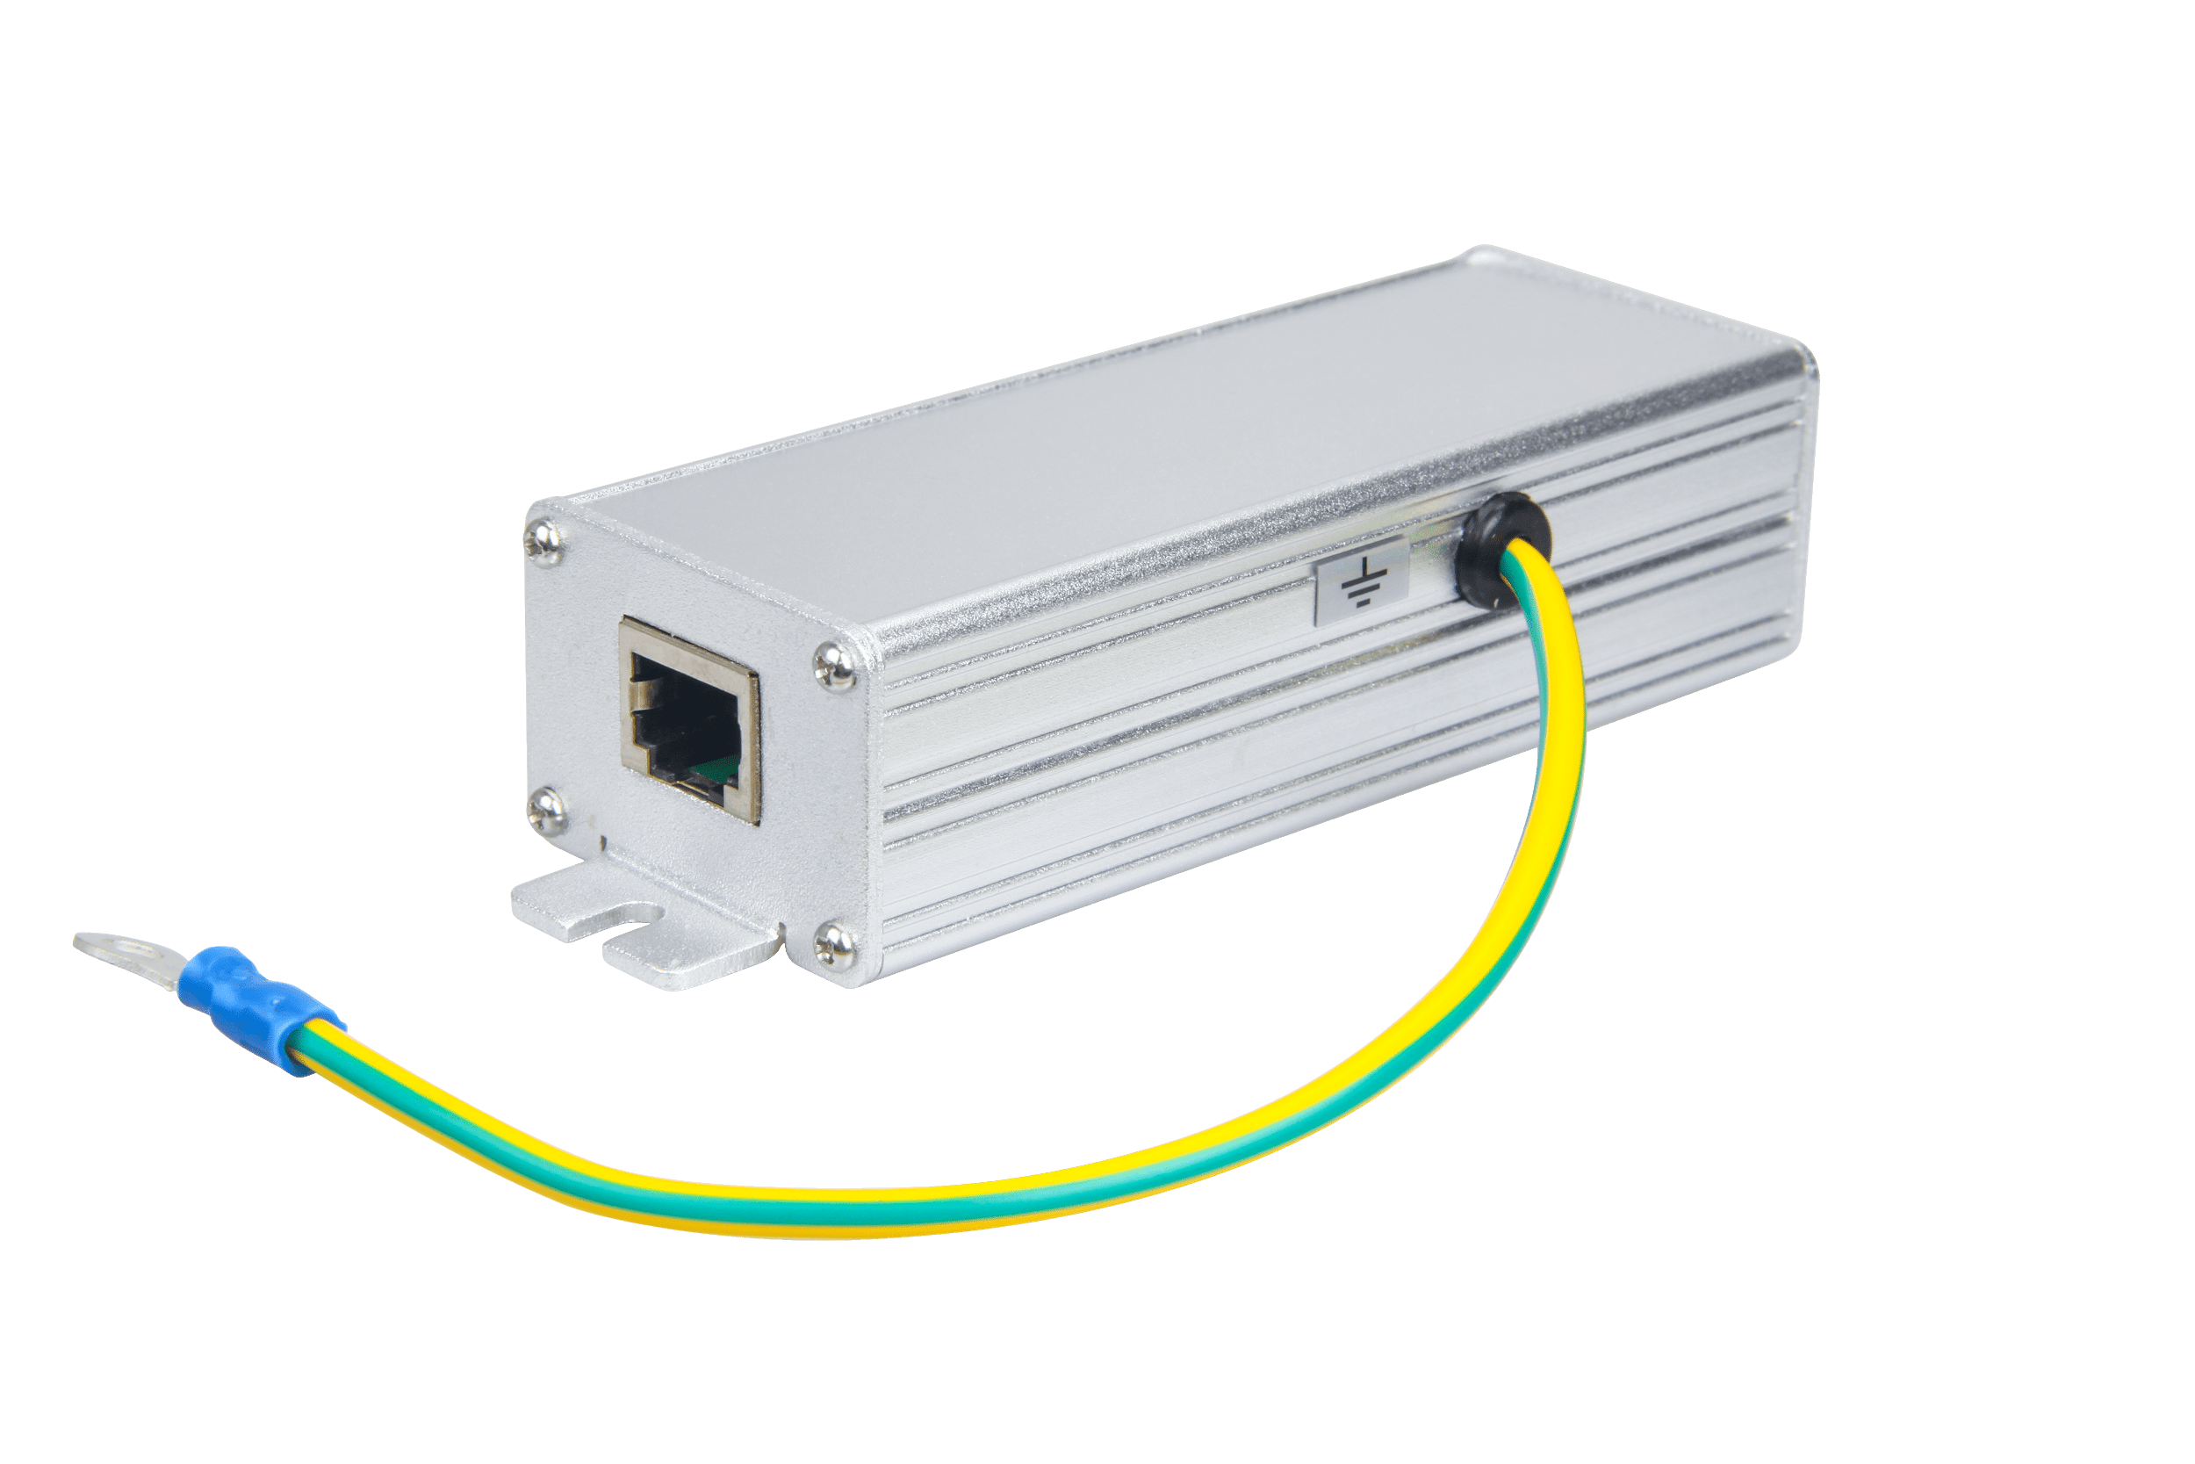

**Figure 24:** Signal Surge Protective Device

[Buy a Signal Surge Protective Device](https://store.rakwireless.com/products/signal-surge-protective)

This surge protective device is suitable to Category 6 cable or Class E cable for protection of equipment from surge and over-voltage induced by lightning or produced in the inner systems. It is widely used in office and industry comprehensive network wiring projects or the similar telecommunication applications, such as Gigabit Ethernet, ATM, ISDN and VoIP systems.

High performance chips with smallest parasitic capacitance are adopted in the product, all line protection for the 8 lines, fast response, giving it a ideal choice for protection of lightning effect.

Multiple stage protection structure provides good protection of lightning effect, the tolerable lightning impulse current is 10 kA(between 8 lines in total to the PE ), the product complies with the related international and domestic standards.

##### [#](https://docs.rakwireless.com/Product-Categories/WisGate/RAK7249/Quickstart/#ethernet-cabling)**Ethernet Cabling**

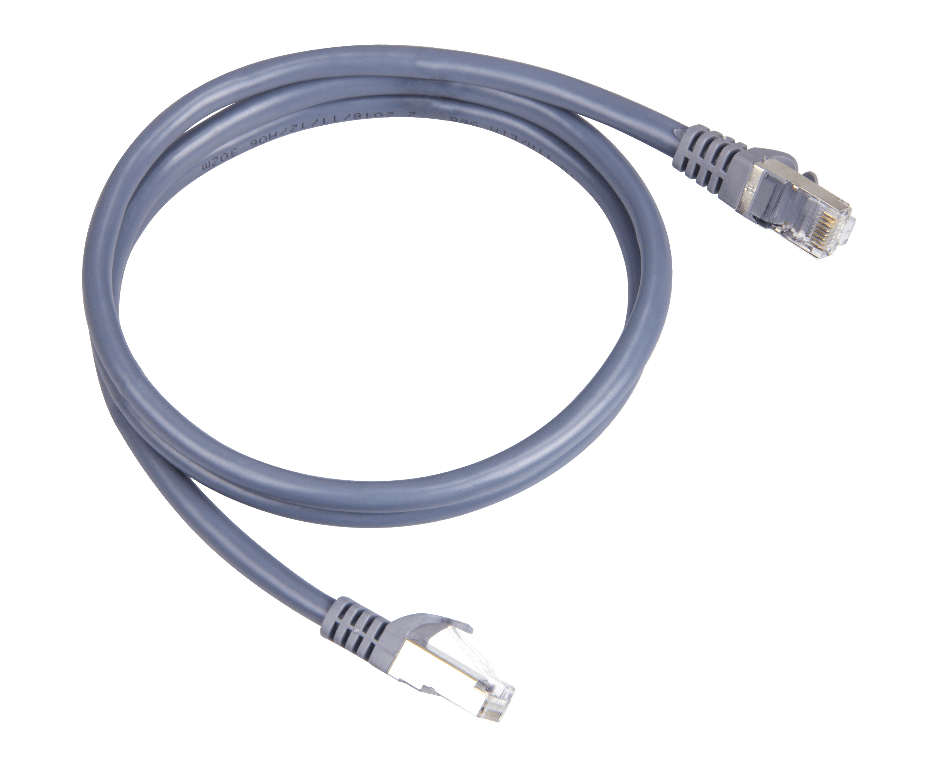

**Figure 25:** Ethernet Cabling

[Buy an Ethernet Cable](https://store.rakwireless.com/products/cat5-ethernet-cable)

CAT5 Ethernet Cable for outdoor surge protection system. It is used for connections between the PoE injector, Ethernet SPD, router/switch, and the Ethernet/PoE port on RAK7249. The length of this product is 1 meter.

### [#](https://docs.rakwireless.com/Product-Categories/WisGate/RAK7249/Quickstart/#power-on-the-gateway)**Power on the Gateway**

In this section, it is assumed that you have read and performed the procedures listed in the Outdoor Deployment Category. Listed below are the individual sections for you to read depending on your Gateway application:

* [Gateway Installation Guide](https://docs.rakwireless.com/Product-Categories/WisGate/RAK7249/Quickstart/#gateway-installation-guide)
* [Solar Panel and Battery Kit Installation](https://docs.rakwireless.com/Product-Categories/WisGate/RAK7249/Quickstart/#solar-panel-and-battery-kit-installation)
* [Lightning Protection](https://docs.rakwireless.com/Product-Categories/WisGate/RAK7249/Quickstart/#lightning-protection)

1. Attach the antennas

First and foremost screw on the antennas. All 5 of them should be installed (WiFi, LoRa, LTE-DIV, LTE-MAIN on the top, and GPS on the bottom) same with the image shown below.

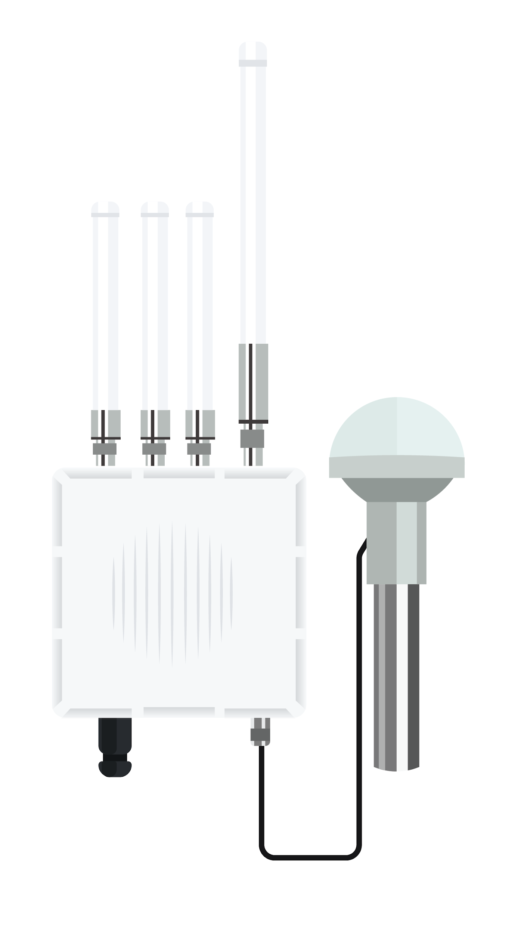

**Figure 26:** RAK7249 WisGate Edge Max with the Antennas installed

⚠️ WARNING

Do not power the device if any antenna port has been left open. In case you do not desire to use one or more antenna feature, make sure to terminate the port with a 50 Ohm load.

1. Power on the Gateway

It is recommended to use a CAT5 Cable to provide power to the Gateway. Attach one end to the PoE injector and the other to the Ethernet Port on the bottom of the casing.

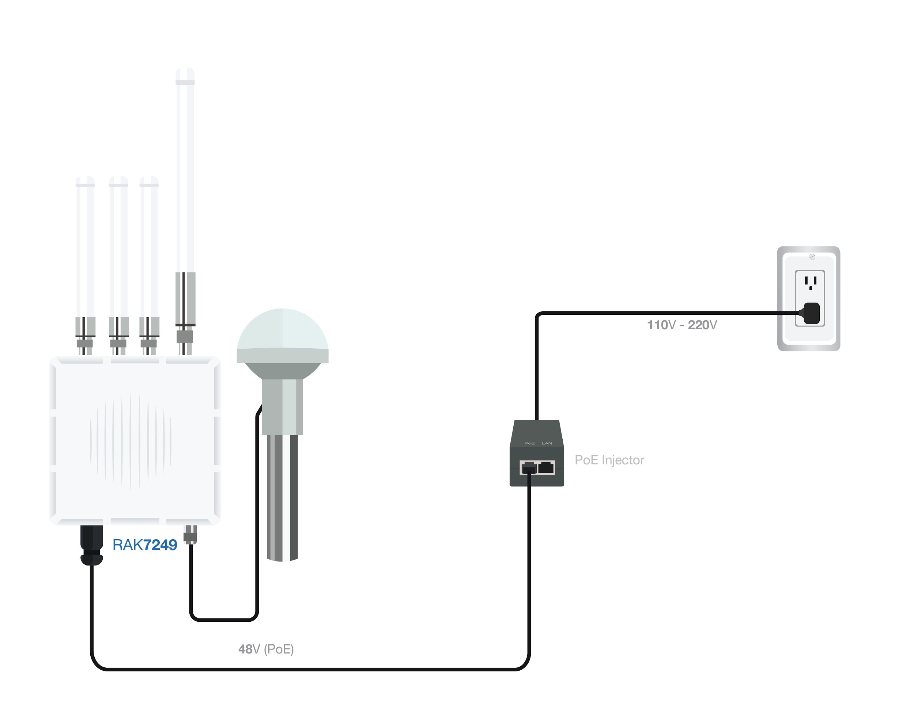

**Figure 27:** Powering the Gateway using PoE

### [#](https://docs.rakwireless.com/Product-Categories/WisGate/RAK7249/Quickstart/#access-the-gateway)**Access the Gateway**

In this section, several ways in accessing the gateway are provided to have different alternatives for you to choose depending on the availability of the requirements needed.

⚠️ WARNING

Do not power the device if the LoRa Antenna port has been left open to avoid potential damage in the RAK7249 WisGate Edge Max."

#### [#](https://docs.rakwireless.com/Product-Categories/WisGate/RAK7249/Quickstart/#wi-fi-ap-mode)**Wi-Fi AP Mode**

By default, the Gateway will work in Wi-Fi AP Mode which means that you can find an SSID named like "RAK7249_XXXX" on your PC's Wi-Fi Network List. "XXXX" is the last two bytes of the Gateway MAC address. To access the Web Management Platform, input the IP Address: 192.168.230.1 in your Web browser.

📝 NOTE

No password is required to connect via Wi-Fi

Using your preferred Web browser, input the aforementioned IP Address and you should see the same Log-in Page shown in the following image. Login the credentials provided below:

* Username: root
* Password: root

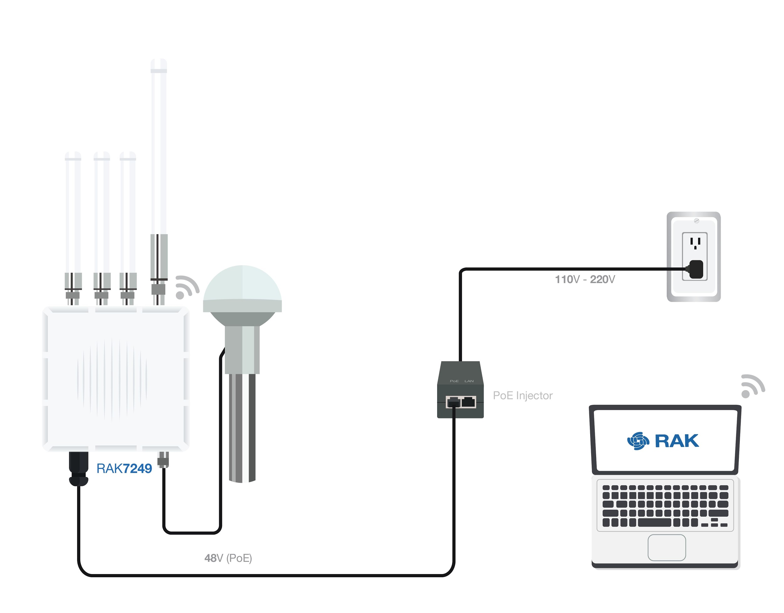

**Figure 28:** Accessing the Gateway via Wi-Fi AP Mode

### [#](https://docs.rakwireless.com/Product-Categories/WisGate/RAK7249/Quickstart/#wan-port-ethernet)**WAN Port (Ethernet)**

Connect the Ethernet cable to the port marked “ETH” on the Gateway and the other end to the PoE port of the PoE injector. Connect the LAN port of the PoE injector to your PC.

The default IP is 169.254.X.X. The last two segments(X.X) are mapped from the last four bits of the MAC address of your gateway. For example, the last four bits of the MAC address are 0F:01, and the IP address is 169.254.15.1. Make sure to manually set the address of your PC to one in the same network (for example 169.254.15.100). Use the same credentials for the Web UI as for AP mode.

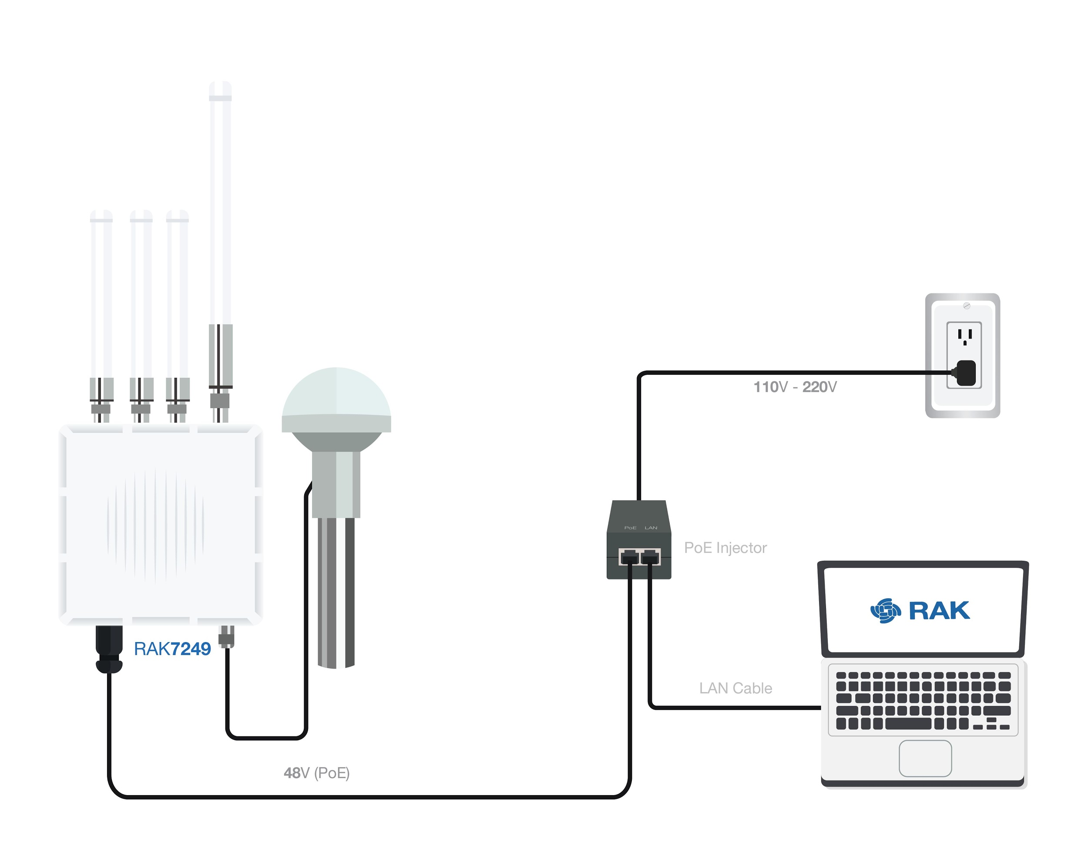

**Figure 29:** Accessing the Gateway via WAN Port (Ethernet)

### [#](https://docs.rakwireless.com/Product-Categories/WisGate/RAK7249/Quickstart/#access-the-internet)**Access the Internet**

#### [#](https://docs.rakwireless.com/Product-Categories/WisGate/RAK7249/Quickstart/#connect-through-wi-fi)**Connect through Wi-Fi**

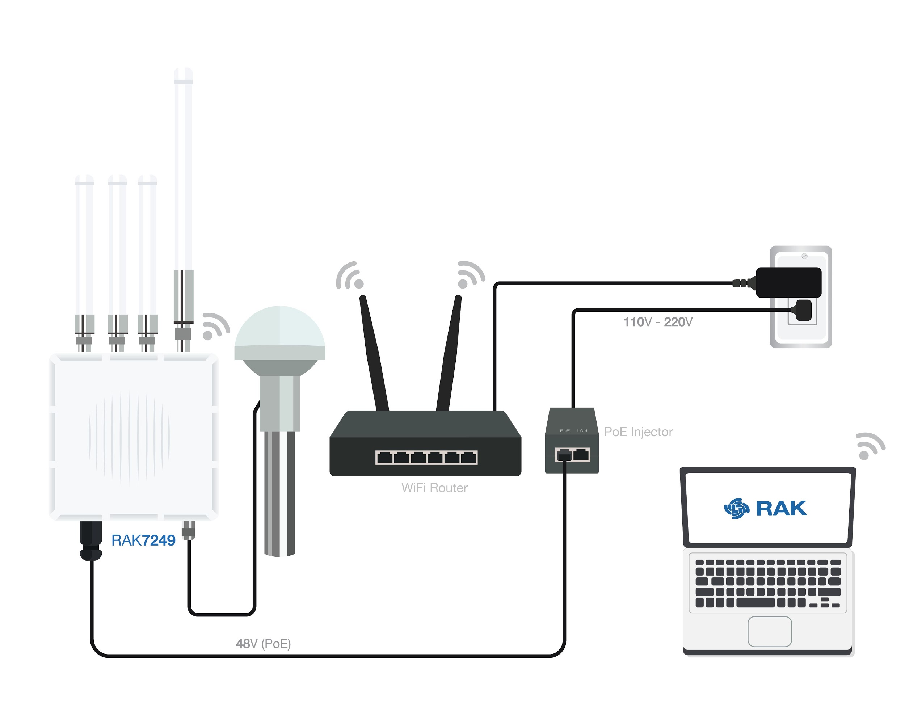

**Figure 30:** Accessing the Internet using Wi-Fi

Go into the Network>Wi-Fi Menu and make sure to enable the Wireless Client as it is disabled initially. Enter or click "Scan" to choose your ESSSID, select the right Encryption method and enter the correct Key.

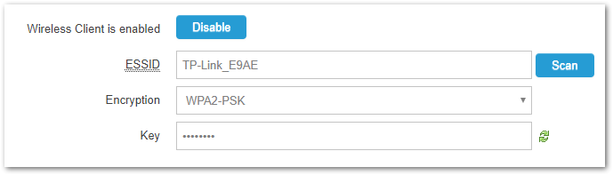

**Figure 31:** Connect through Wi-Fi Credentials

📝 NOTE

Assuming you have entered the correct parameter values you should get an IP address assigned by your Wi-Fi router's (AP) built-in DHCP server. You can use this new IP address to log in via a web browser (same way as in AP mode).

#### [#](https://docs.rakwireless.com/Product-Categories/WisGate/RAK7249/Quickstart/#connect-through-ethernet-poe)**Connect through Ethernet/PoE**

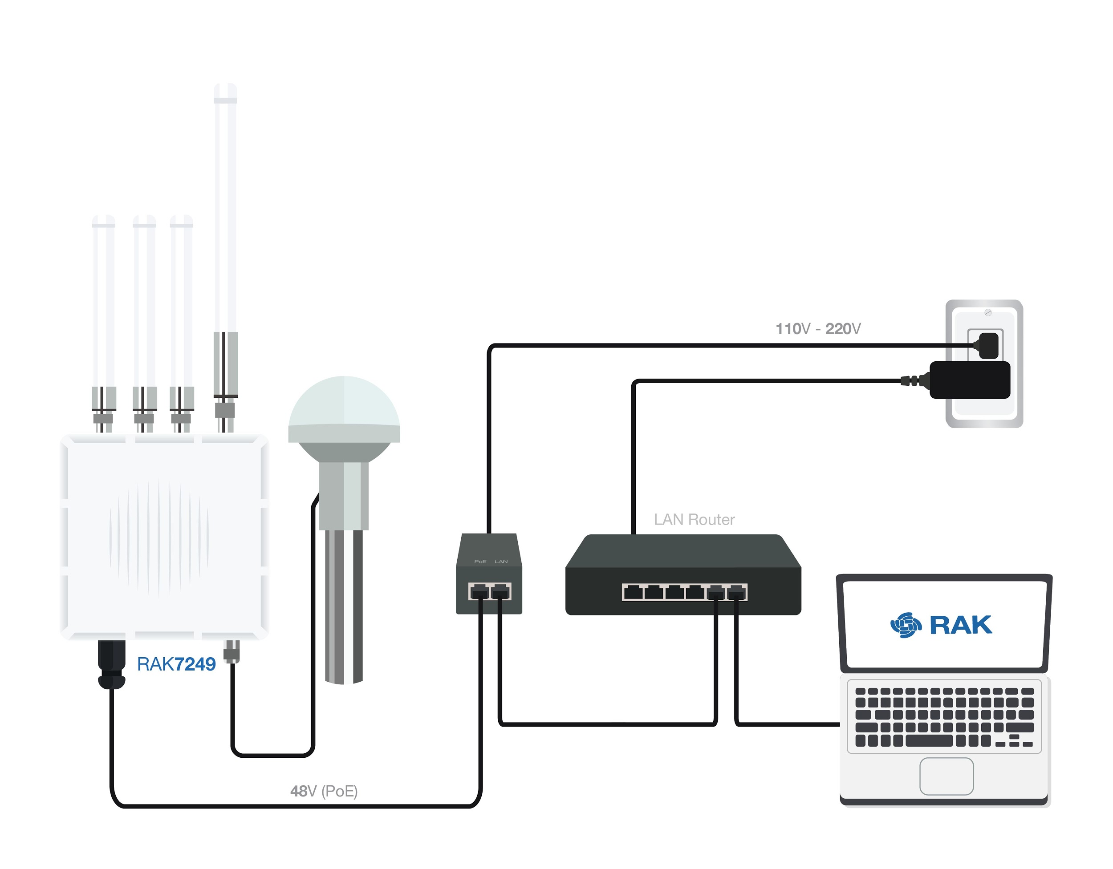

**Figure 32:** Accessing the Internet through Ethernet

Connect the Ethernet cable to the port marked “ETH” on the Gateway and the other end to the PoE port of the PoE injector. Connect the LAN port of the PoE injector to your router. The router’s DHCP server should assign an IP Address to the Gateway. You can change the default settings below if you wish (details in the User Manual).

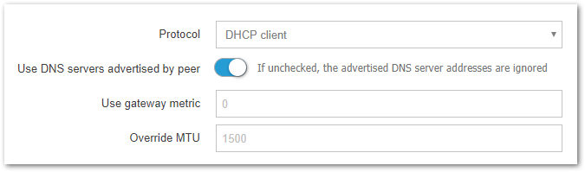

**Figure 33:** Connect through Ethernet Settings

### [#](https://docs.rakwireless.com/Product-Categories/WisGate/RAK7249/Quickstart/#connecting-to-the-things-network-ttn)**Connecting to The Things Network (TTN)**

The Things Network is about enabling low power devices to use long range gateways to connect to an open-source, decentralized network to exchange data with Application. Learn more about The Things Network through their [documentation](https://www.thethingsnetwork.org/docs/).

* First, you should have connected your RAK7249 WisGate Edge Max to the router into the internet through a router according to the method which has been introduced in the [Access the Internet](https://docs.rakwireless.com/Product-Categories/WisGate/RAK7249/Quickstart/#access-the-internet) section of this document.
* Now go to the TTN Website: <https://www.thethingsnetwork.org/> and Login. You will then see the following page:



**Figure 34:** The Things Network Home Page

1. In the Register Gateway menu, select the “I’m using the legacy packet forwarder” option, and fill-in the Gateway EUI.

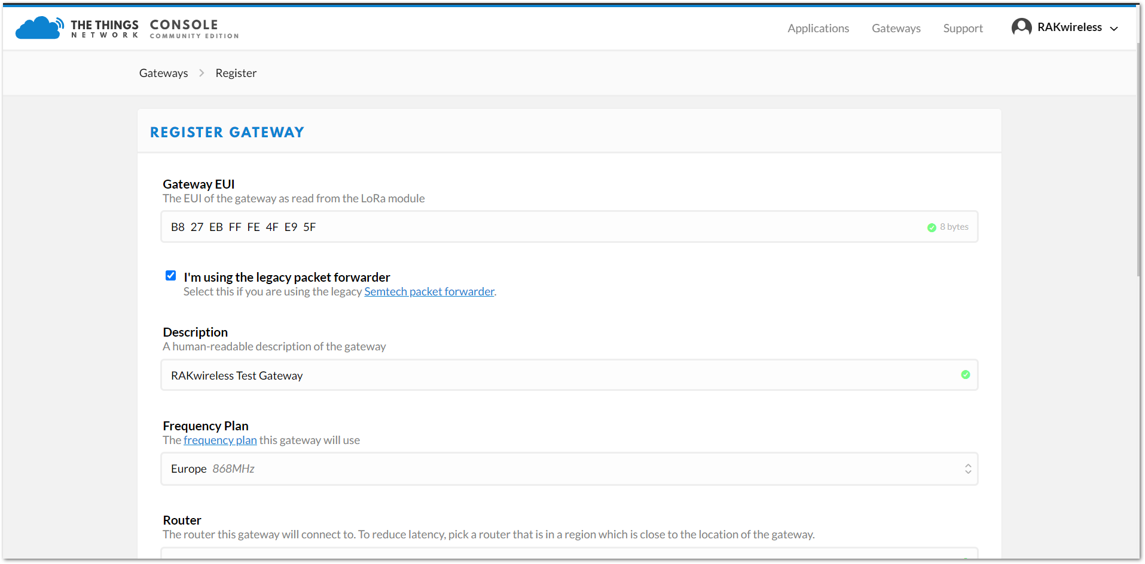

**Figure 35:** Registering your Gateway

📝 NOTE

The Gateway EUI can be found either on the sticker on the casing or via the LoRa Packet Forwarder page in the Gateway menu once you log via the Web UI.

1. Select your [Frequency Plan](https://www.thethingsnetwork.org/docs/lorawan/frequency-plans.html) depending on your location. This should populate the Router field. Optionally you can choose to enter the Gateway coordinates in the map’s upper right corner and select if the gateway is indoor or outdoor via the Antenna placement field below the map.
2. Upon successful registration you should see the following screen:

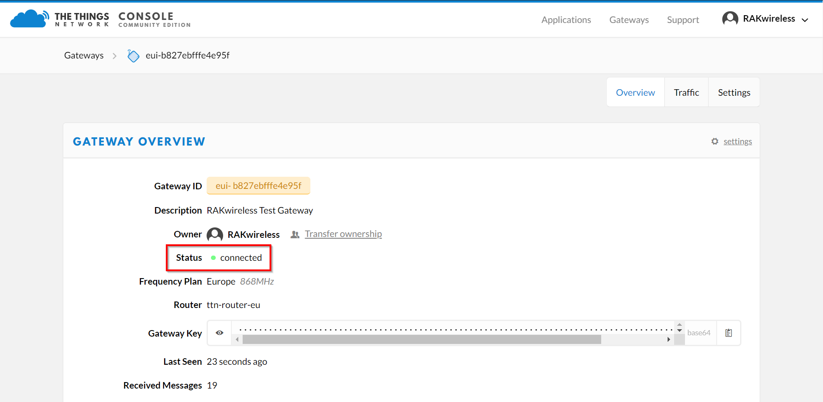

**Figure 36:** Gateway successfully connected to The Things Network (TTN)

📝 NOTE

By default, the Gateway is set to connect to TTN. For detailed information about advanced configuration options refer to the [WEB Management Platform - LoRa Network](https://docs.rakwireless.com/Knowledge-Hub/Learn/Resources/WEB-Management-Platform/#lora%C2%AE-network) section.

[Edit this page in GitHub](https://github.com/RAKWireless/rakwireless-docs/edit/master/docs/Product-Categories/WisGate/RAK7249/Quickstart/README.md)

Last Updated: 9/13/2020, 2:53:36 PM